**Computer Networking**

**Basic task:**

**1.basics of terminal:**

Listing network interfaces:

Command: `ipconfig`

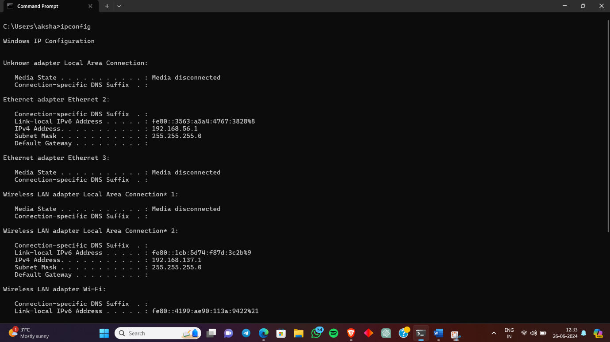

**Display Interface Configuration:**

Command: `ipconfig/all

Displays all current TCP/IP network configuration values and refreshes DHCP and DNS settings. 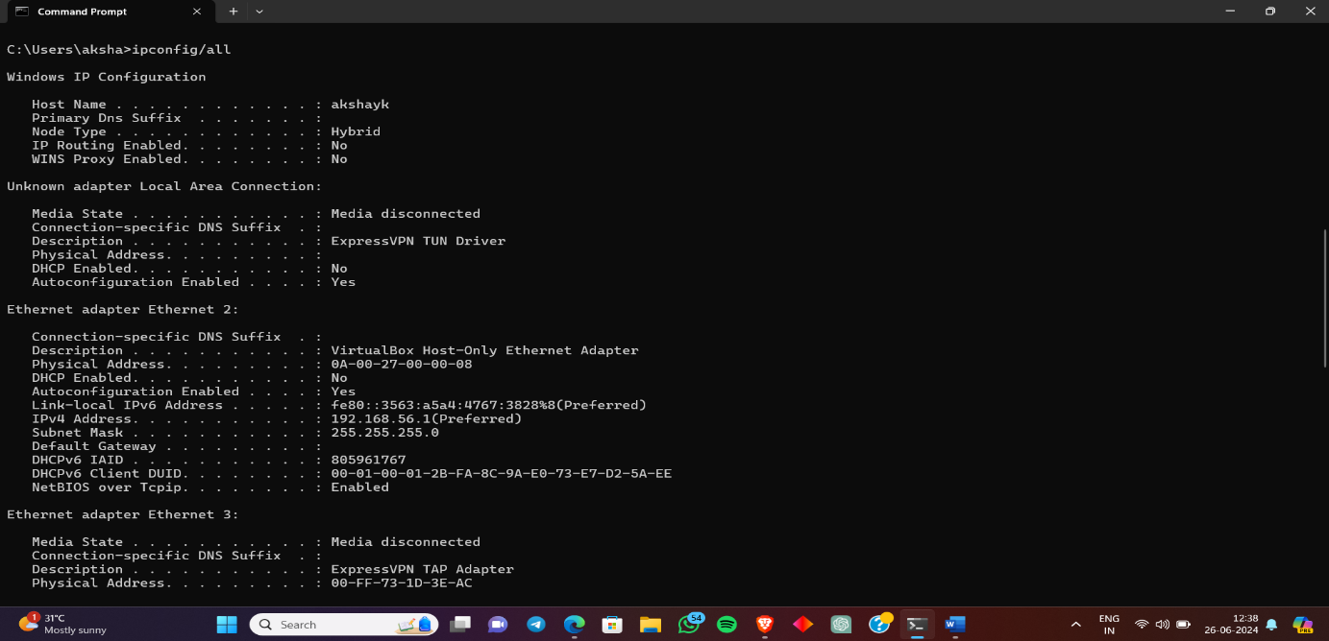

**Output**: Lists all network interfaces, IP addresses, subnet masks, default gateways, and MAC addresses.

Assign a Static IP Address:

Command: ` netsh interface ipv4 set address name="Local Area Connection" static 192.168.1.201 255.255.255.0 192.168.1.1

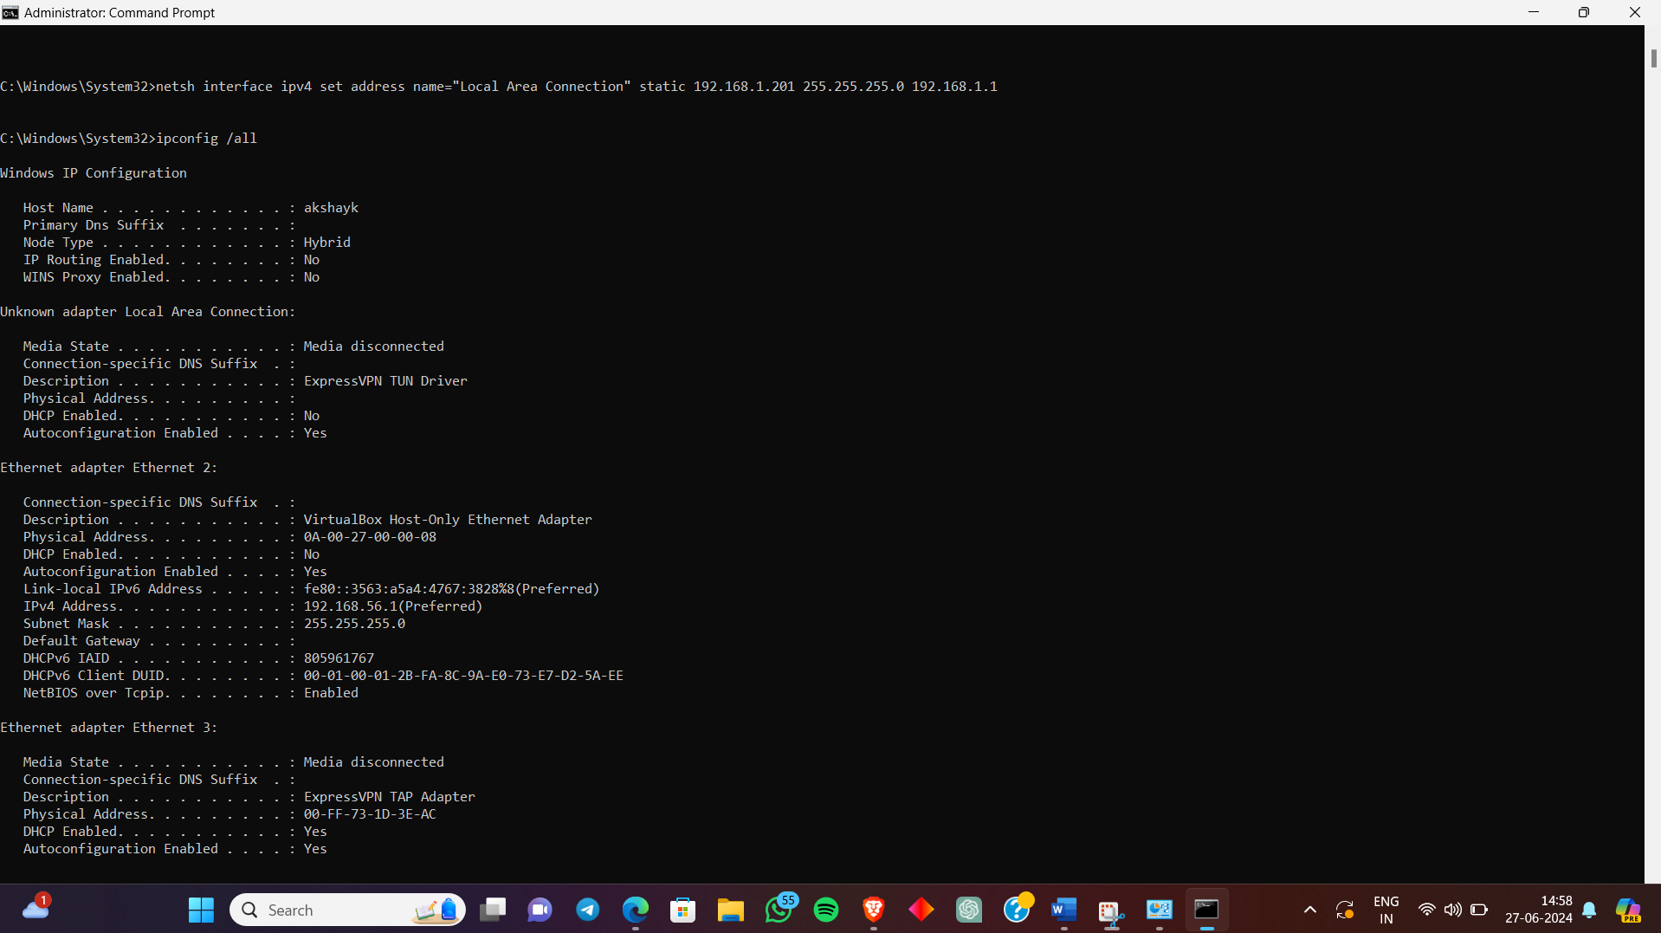

Sets a static IP address, subnet mask, and default gateway for the specified network interface.

Ping a Remote Server:

Command: `ping www.google.com`

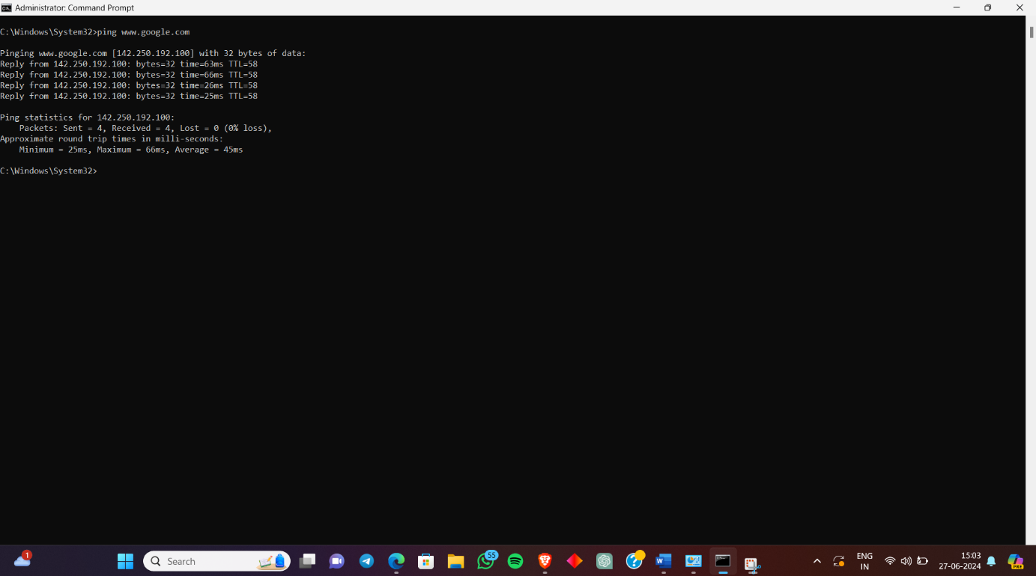

Shows packets sent, received, lost, and round trip time (minimum, maximum, average).

Perform a Traceroute to a Remote Server like [www.google.com](http://www.google.com):

Command: ` tracert www.google.com`

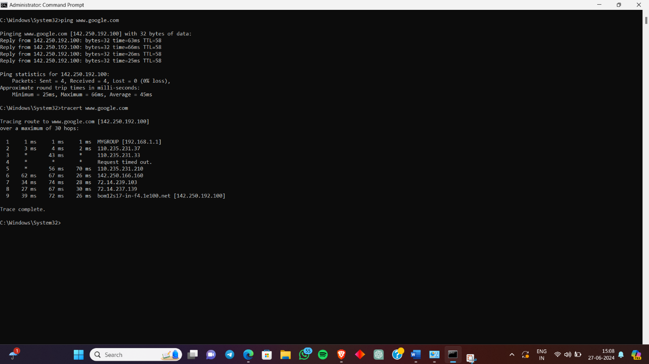

Traces the path that packets take from your computer to the target address and displays each hop along the route and the time it takes to reach each hop.